Bampton and District Local History Society members’ meetings
The Mardale: Path to Community Ownership
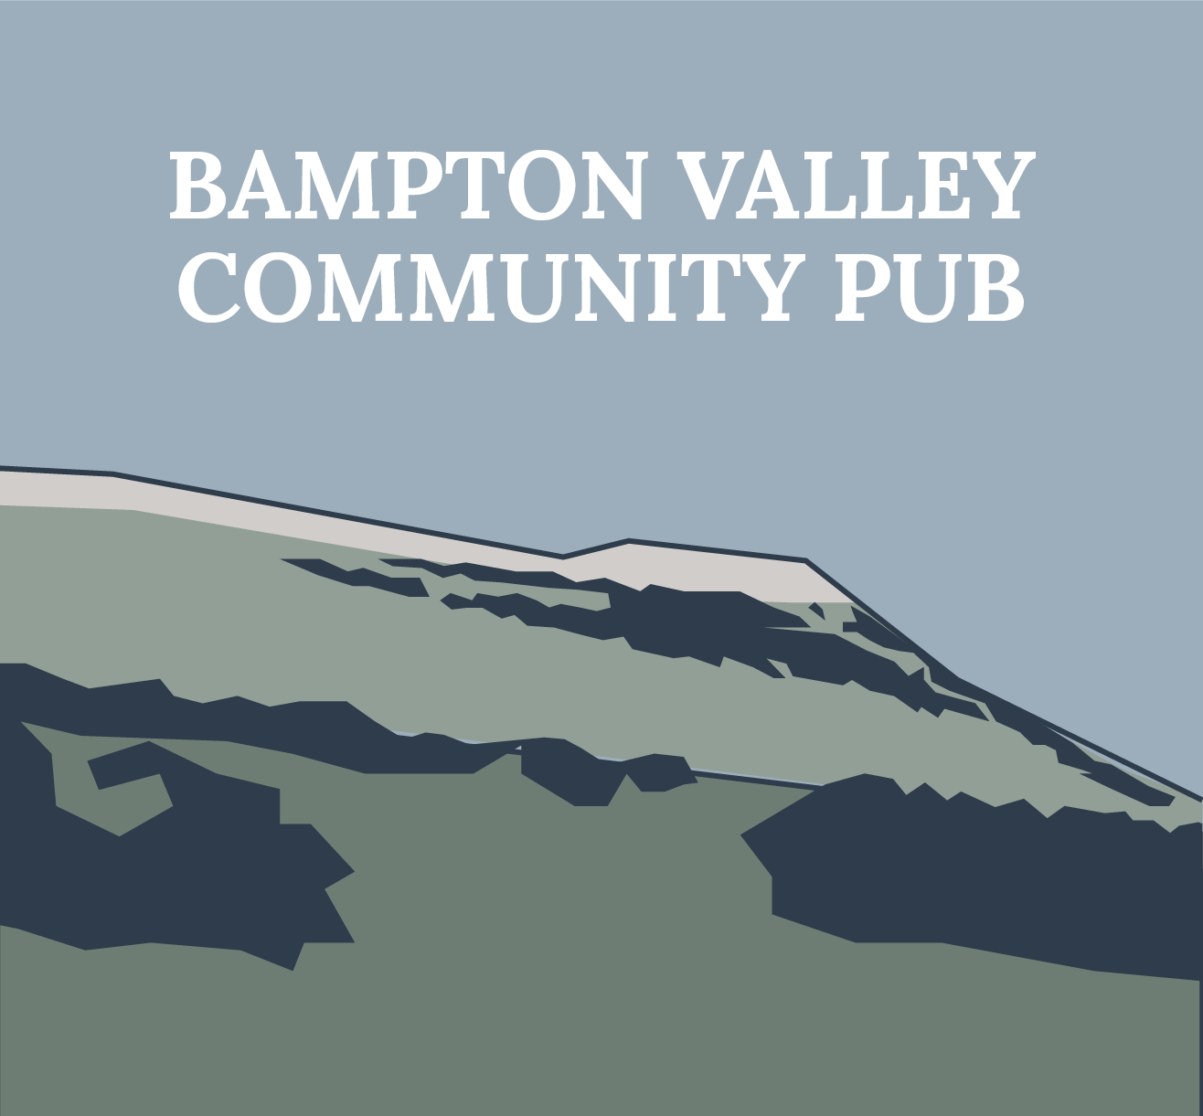
Phil Sweetland
Tuesday 5th December
2:00pm
at The Mardale Inn, Bampton
We invite you to bring memories, photographs, press cuttings, reminiscences of The Mardale Inn

Everyone welcome!
The fire will be lit; tea, coffee and cakes are free of charge. Drinks available to buy at the bar so bring your loyalty card

